# No Augment Model

import tensorflow as tf

# Hyperparameters yang disarankan

layer_unit = 32 # Kapasitas layer

dropout_val = 0.2 # Sedikit menurunkan dropout

batch_size = 64 # Batch lebih kecil untuk stabilitas

learning_rate = 1e-6 # Sedikit menurunkan learning rate

initial_lr = 1e-4 # Learning rate awal sebelum warmup

weight_decay = 0.01 # Tetap

gamma = 3 # Meningkatkan gamma untuk penalti kelas minoritas

alpha = 0.25 # Tetap

epochs = 8 # Tetap, sesuaikan sesuai kebutuhan

activation_function = 'gelu'

l2_values = tf.keras.regularizers.l2(0.003)

🟢 Warmup: Setting learning rate to 0.000100

Epoch 1/8

126/126 [==============================] - 159s 961ms/step - loss: 1.7413 - accuracy: 0.6400 - recall: 0.5622 - precision: 0.8235 - f1_score: 0.6084 - val_loss: 0.9606 - val_accuracy: 0.8074 - val_recall: 0.7839 - val_precision: 0.8526 - val_f1_score: 0.7956 - lr: 1.0000e-04

🟢 Warmup: Setting learning rate to 0.000080

Epoch 2/8

126/126 [==============================] - 118s 934ms/step - loss: 0.7636 - accuracy: 0.8586 - recall: 0.8294 - precision: 0.9062 - f1_score: 0.8420 - val_loss: 0.8616 - val_accuracy: 0.8320 - val_recall: 0.8141 - val_precision: 0.8834 - val_f1_score: 0.8078 - lr: 8.0200e-05

🟢 Warmup: Setting learning rate to 0.000060

Epoch 3/8

126/126 [==============================] - 117s 932ms/step - loss: 0.4857 - accuracy: 0.9217 - recall: 0.9065 - precision: 0.9488 - f1_score: 0.9122 - val_loss: 0.8148 - val_accuracy: 0.8589 - val_recall: 0.8522 - val_precision: 0.8849 - val_f1_score: 0.8580 - lr: 6.0400e-05

🟢 Warmup: Setting learning rate to 0.000041

Epoch 4/8

126/126 [==============================] - 117s 929ms/step - loss: 0.3591 - accuracy: 0.9571 - recall: 0.9486 - precision: 0.9692 - f1_score: 0.9568 - val_loss: 0.8339 - val_accuracy: 0.8701 - val_recall: 0.8690 - val_precision: 0.9013 - val_f1_score: 0.8705 - lr: 4.0600e-05

🟢 Warmup: Setting learning rate to 0.000021

Epoch 5/8

126/126 [==============================] - 117s 930ms/step - loss: 0.2732 - accuracy: 0.9808 - recall: 0.9769 - precision: 0.9868 - f1_score: 0.9809 - val_loss: 0.8399 - val_accuracy: 0.8701 - val_recall: 0.8679 - val_precision: 0.8867 - val_f1_score: 0.8718 - lr: 2.0800e-05

🔵 Learning rate after warmup: 0.000021

Epoch 6/8

126/126 [==============================] - ETA: 0s - loss: 0.2457 - accuracy: 0.9886 - recall: 0.9863 - precision: 0.9924 - f1_score: 0.9878

Epoch 6: ReduceLROnPlateau reducing learning rate to 1.0400000064691994e-05.

126/126 [==============================] - 117s 930ms/step - loss: 0.2457 - accuracy: 0.9886 - recall: 0.9863 - precision: 0.9924 - f1_score: 0.9878 - val_loss: 0.8508 - val_accuracy: 0.8723 - val_recall: 0.8645 - val_precision: 0.8894 - val_f1_score: 0.8738 - lr: 2.0800e-05

🔵 Learning rate after warmup: 0.000010

Epoch 7/8

126/126 [==============================] - 117s 930ms/step - loss: 0.2331 - accuracy: 0.9929 - recall: 0.9909 - precision: 0.9952 - f1_score: 0.9929 - val_loss: 0.8641 - val_accuracy: 0.8656 - val_recall: 0.8634 - val_precision: 0.8811 - val_f1_score: 0.8641 - lr: 1.0400e-05

🔵 Learning rate after warmup: 0.000010

Epoch 8/8

126/126 [==============================] - ETA: 0s - loss: 0.2272 - accuracy: 0.9933 - recall: 0.9927 - precision: 0.9948 - f1_score: 0.9931Restoring model weights from the end of the best epoch: 3.

126/126 [==============================] - 118s 933ms/step - loss: 0.2272 - accuracy: 0.9933 - recall: 0.9927 - precision: 0.9948 - f1_score: 0.9931 - val_loss: 0.8732 - val_accuracy: 0.8679 - val_recall: 0.8634 - val_precision: 0.8842 - val_f1_score: 0.8676 - lr: 1.0400e-05

Epoch 8: early stopping

14/14 [==============================] - 7s 297ms/step

precision recall f1-score support

Account & Customer Information Management 0.9677 0.8571 0.9091 35

After Sales & Service Termination 1.0000 0.8889 0.9412 9

Application Usage 0.8718 0.8095 0.8395 42

Billing 0.9545 0.9333 0.9438 45

Business Training and Webinar 0.9444 0.8500 0.8947 20

Call Center 0.8684 0.9429 0.9041 35

Competitors 0.9565 0.9167 0.9362 24

Customer ID Number 0.6000 0.7500 0.6667 4

Discount & Referral Incentive 1.0000 1.0000 1.0000 14

Disturbance Report 1.0000 0.7826 0.8780 23

FUP Indibiz 1.0000 1.0000 1.0000 16

General Business Information 0.5556 0.3846 0.4545 13

IP Services 0.9524 0.9524 0.9524 21

Indibiz Package 0.6275 0.8000 0.7033 40

Internet Speed 0.8333 1.0000 0.9091 15

Irrelevant Question 0.4286 0.4286 0.4286 14

Modem 0.8182 0.7500 0.7826 12

New Installation 0.8000 1.0000 0.8889 8

Number on Application 0.9737 0.9737 0.9737 38

Optical Distribution Point 1.0000 1.0000 1.0000 5

Order & Subscription Information 0.8276 0.7742 0.8000 31

Others 0.8000 0.4444 0.5714 9

Package Information 0.9524 0.7843 0.8602 51

Package Migration 1.0000 0.7857 0.8800 14

Price 0.8421 0.9412 0.8889 17

Product & Package Differences 1.0000 0.9000 0.9474 10

Product Advantages and Disadvantages 1.0000 0.9355 0.9667 31

Product Installation 0.8913 0.8913 0.8913 46

Product Reseller 1.0000 1.0000 1.0000 5

Products & Services 0.6429 0.8491 0.7317 53

Service Availability 0.8667 0.8864 0.8764 44

Technician Survey 0.9412 1.0000 0.9697 16

Transaction Number 1.0000 0.7500 0.8571 4

Unclear Context 0.7111 0.8205 0.7619 39

Unclear Words 0.8718 0.9444 0.9067 36

Upgrading and Downgrading 0.8750 0.8400 0.8571 25

Vertical Business Education 1.0000 0.8889 0.9412 9

myIndibiz B2B Products 1.0000 0.8000 0.8889 20

accuracy 0.8589 893

macro avg 0.8783 0.8488 0.8580 893

weighted avg 0.8702 0.8589 0.8601 893

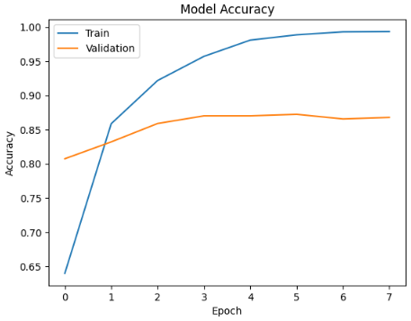

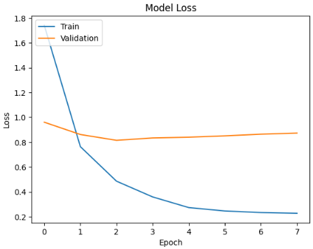

Accuracy: 0.8489425981873112

Precision: 0.8514735470582878

Recall: 0.8336356563167522

F1 Score: 0.8360293798939759

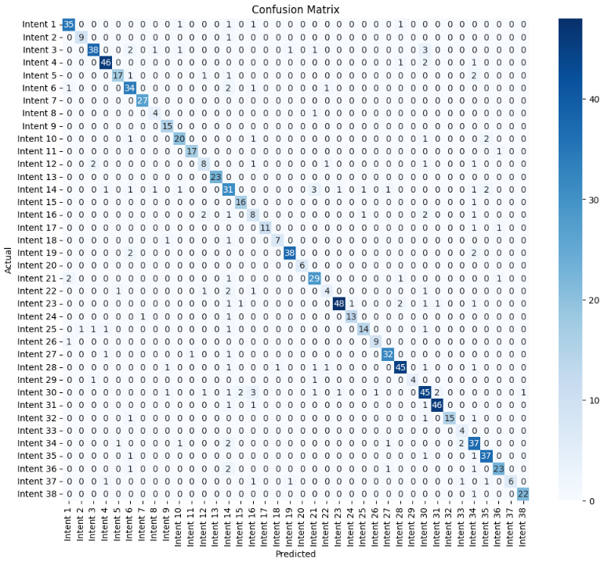

Intent: Account & Customer Information Management

Accuracy: 0.99

Precision: 0.90

Recall: 0.90

F1 Score: 0.90

Intent: After Sales & Service Termination

Accuracy: 1.00

Precision: 0.90

Recall: 0.90

F1 Score: 0.90

Intent: Application Usage

Accuracy: 0.99

Precision: 0.90

Recall: 0.81

F1 Score: 0.85

Intent: Billing

Accuracy: 0.99

Precision: 0.92

Recall: 0.92

F1 Score: 0.92

Intent: Business Training and Webinar

Accuracy: 0.99

Precision: 0.89

Recall: 0.77

F1 Score: 0.83

Intent: Call Center

Accuracy: 0.98

Precision: 0.77

Recall: 0.87

F1 Score: 0.82

Intent: Competitors

Accuracy: 1.00

Precision: 0.96

Recall: 1.00

F1 Score: 0.98

Intent: Customer ID Number

Accuracy: 1.00

Precision: 0.67

Recall: 0.80

F1 Score: 0.73

Intent: Discount & Referral Incentive

Accuracy: 1.00

Precision: 0.83

Recall: 1.00

F1 Score: 0.91

Intent: Disturbance Report

Accuracy: 0.99

Precision: 0.83

Recall: 0.80

F1 Score: 0.82

Intent: FUP Indibiz

Accuracy: 1.00

Precision: 0.94

Recall: 0.94

F1 Score: 0.94

Intent: General Business Information

Accuracy: 0.99

Precision: 0.62

Recall: 0.57

F1 Score: 0.59

Intent: IP Services

Accuracy: 1.00

Precision: 1.00

Recall: 1.00

F1 Score: 1.00

Intent: Indibiz Package

Accuracy: 0.97

Precision: 0.60

Recall: 0.70

F1 Score: 0.65

Intent: Internet Speed

Accuracy: 1.00

Precision: 0.84

Recall: 0.94

F1 Score: 0.89

Intent: Irrelevant Question

Accuracy: 0.98

Precision: 0.44

Recall: 0.53

F1 Score: 0.48

Intent: Modem

Accuracy: 1.00

Precision: 1.00

Recall: 0.85

F1 Score: 0.92

Intent: New Installation

Accuracy: 1.00

Precision: 0.88

Recall: 0.78

F1 Score: 0.82

Intent: Number on Application

Accuracy: 0.99

Precision: 0.95

Recall: 0.90

F1 Score: 0.93

Intent: Optical Distribution Point

Accuracy: 1.00

Precision: 1.00

Recall: 1.00

F1 Score: 1.00

Intent: Order & Subscription Information

Accuracy: 0.99

Precision: 0.78

Recall: 0.85

F1 Score: 0.82

Intent: Others

Accuracy: 0.99

Precision: 0.57

Recall: 0.40

F1 Score: 0.47

Intent: Package Information

Accuracy: 0.99

Precision: 0.96

Recall: 0.86

F1 Score: 0.91

Intent: Package Migration

Accuracy: 1.00

Precision: 0.93

Recall: 0.87

F1 Score: 0.90

Intent: Price

Accuracy: 0.99

Precision: 0.88

Recall: 0.74

F1 Score: 0.80

Intent: Product & Package Differences

Accuracy: 1.00

Precision: 0.90

Recall: 0.90

F1 Score: 0.90

Intent: Product Advantages and Disadvantages

Accuracy: 0.99

Precision: 0.91

Recall: 0.91

F1 Score: 0.91

Intent: Product Installation

Accuracy: 0.99

Precision: 0.90

Recall: 0.87

F1 Score: 0.88

Intent: Product Reseller

Accuracy: 1.00

Precision: 1.00

Recall: 0.67

F1 Score: 0.80

Intent: Products & Services

Accuracy: 0.97

Precision: 0.74

Recall: 0.76

F1 Score: 0.75

Intent: Service Availability

Accuracy: 0.99

Precision: 0.94

Recall: 0.94

F1 Score: 0.94

Intent: Technician Survey

Accuracy: 1.00

Precision: 1.00

Recall: 0.83

F1 Score: 0.91

Intent: Transaction Number

Accuracy: 1.00

Precision: 0.57

Recall: 1.00

F1 Score: 0.73

Intent: Unclear Context

Accuracy: 0.98

Precision: 0.70

Recall: 0.84

F1 Score: 0.76

Intent: Unclear Words

Accuracy: 0.99

Precision: 0.88

Recall: 0.93

F1 Score: 0.90

Intent: Upgrading and Downgrading

Accuracy: 0.99

Precision: 0.88

Recall: 0.82

F1 Score: 0.85

Intent: Vertical Business Education

Accuracy: 0.99

Precision: 1.00

Recall: 0.55

F1 Score: 0.71

Intent: myIndibiz B2B Products

Accuracy: 1.00

Precision: 0.96

Recall: 0.96

F1 Score: 0.96

# Augment Model

🟢 Warmup: Setting learning rate to 0.000100

Epoch 1/8

165/165 [==============================] - 211s 968ms/step - loss: 2.1557 - accuracy: 0.5747 - recall: 0.5296 - precision: 0.6606 - f1_score: 0.5581 - val_loss: 4.6810 - val_accuracy: 0.2486 - val_recall: 0.2273 - val_precision: 0.3745 - val_f1_score: 0.2931 - lr: 1.0000e-04

🟢 Warmup: Setting learning rate to 0.000080

Epoch 2/8

165/165 [==============================] - 155s 939ms/step - loss: 1.0596 - accuracy: 0.7806 - recall: 0.7474 - precision: 0.8444 - f1_score: 0.7893 - val_loss: 3.3986 - val_accuracy: 0.3908 - val_recall: 0.3527 - val_precision: 0.4716 - val_f1_score: 0.4419 - lr: 8.0200e-05

🟢 Warmup: Setting learning rate to 0.000060

Epoch 3/8

165/165 [==============================] - 155s 940ms/step - loss: 0.7476 - accuracy: 0.8558 - recall: 0.8343 - precision: 0.8996 - f1_score: 0.8612 - val_loss: 2.6530 - val_accuracy: 0.5151 - val_recall: 0.4759 - val_precision: 0.6080 - val_f1_score: 0.5272 - lr: 6.0400e-05

🟢 Warmup: Setting learning rate to 0.000041

Epoch 4/8

165/165 [==============================] - 155s 940ms/step - loss: 0.6232 - accuracy: 0.8853 - recall: 0.8652 - precision: 0.9189 - f1_score: 0.8921 - val_loss: 2.5468 - val_accuracy: 0.5633 - val_recall: 0.5230 - val_precision: 0.6202 - val_f1_score: 0.5657 - lr: 4.0600e-05

🟢 Warmup: Setting learning rate to 0.000021

Epoch 5/8

165/165 [==============================] - 155s 939ms/step - loss: 0.5741 - accuracy: 0.8989 - recall: 0.8807 - precision: 0.9262 - f1_score: 0.9043 - val_loss: 2.2466 - val_accuracy: 0.5745 - val_recall: 0.5487 - val_precision: 0.6331 - val_f1_score: 0.5833 - lr: 2.0800e-05

🔵 Learning rate after warmup: 0.000021

Epoch 6/8

165/165 [==============================] - 155s 940ms/step - loss: 0.5663 - accuracy: 0.9017 - recall: 0.8840 - precision: 0.9243 - f1_score: 0.9063 - val_loss: 1.7414 - val_accuracy: 0.6495 - val_recall: 0.6181 - val_precision: 0.6900 - val_f1_score: 0.6512 - lr: 2.0800e-05

🔵 Learning rate after warmup: 0.000021

Epoch 7/8

165/165 [==============================] - 155s 939ms/step - loss: 0.4297 - accuracy: 0.9330 - recall: 0.9206 - precision: 0.9503 - f1_score: 0.9387 - val_loss: 1.5468 - val_accuracy: 0.6920 - val_recall: 0.6585 - val_precision: 0.7368 - val_f1_score: 0.6934 - lr: 2.0800e-05

🔵 Learning rate after warmup: 0.000021

Epoch 8/8

165/165 [==============================] - 154s 936ms/step - loss: 0.3549 - accuracy: 0.9536 - recall: 0.9441 - precision: 0.9638 - f1_score: 0.9570 - val_loss: 1.5639 - val_accuracy: 0.6876 - val_recall: 0.6663 - val_precision: 0.7283 - val_f1_score: 0.6928 - lr: 2.0800e-05

14/14 [==============================] - 8s 309ms/step

precision recall f1-score support

Account & Customer Information Management 1.0000 0.4571 0.6275 35

After Sales & Service Termination 0.7273 0.8889 0.8000 9

Application Usage 0.9615 0.5952 0.7353 42

Billing 1.0000 0.8889 0.9412 45

Business Training and Webinar 0.8095 0.8500 0.8293 20

Call Center 0.9655 0.8000 0.8750 35

Competitors 0.9091 0.8333 0.8696 24

Customer ID Number 0.3000 0.7500 0.4286 4

Discount & Referral Incentive 0.8125 0.9286 0.8667 14

Disturbance Report 0.6774 0.9130 0.7778 23

FUP Indibiz 0.9412 1.0000 0.9697 16

General Business Information 0.4348 0.7692 0.5556 13

IP Services 0.9091 0.9524 0.9302 21

Indibiz Package 1.0000 0.2000 0.3333 40

Internet Speed 0.5556 1.0000 0.7143 15

Irrelevant Question 0.4286 0.6429 0.5143 14

Modem 0.1364 0.7500 0.2308 12

New Installation 0.1228 0.8750 0.2154 8

Number on Application 1.0000 0.1842 0.3111 38

Optical Distribution Point 1.0000 1.0000 1.0000 5

Order & Subscription Information 0.9167 0.7097 0.8000 31

Others 0.2059 0.7778 0.3256 9

Package Information 0.8421 0.6275 0.7191 51

Package Migration 0.6111 0.7857 0.6875 14

Price 0.5357 0.8824 0.6667 17

Product & Package Differences 0.6000 0.9000 0.7200 10

Product Advantages and Disadvantages 0.9375 0.9677 0.9524 31

Product Installation 0.0000 0.0000 0.0000 46

Product Reseller 0.7143 1.0000 0.8333 5

Products & Services 0.8140 0.6604 0.7292 53

Service Availability 0.9070 0.8864 0.8966 44

Technician Survey 0.8889 1.0000 0.9412 16

Transaction Number 0.5714 1.0000 0.7273 4

Unclear Context 1.0000 0.4872 0.6552 39

Unclear Words 0.8667 0.7222 0.7879 36

Upgrading and Downgrading 0.8519 0.9200 0.8846 25

Vertical Business Education 0.5714 0.8889 0.6957 9

myIndibiz B2B Products 0.7619 0.8000 0.7805 20

accuracy 0.6876 893

macro avg 0.7181 0.7709 0.6928 893

weighted avg 0.7924 0.6876 0.6912 893

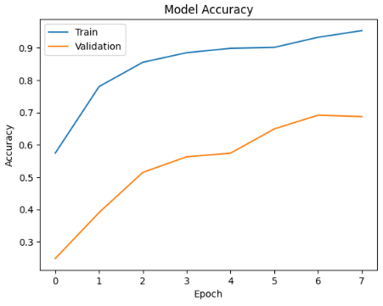

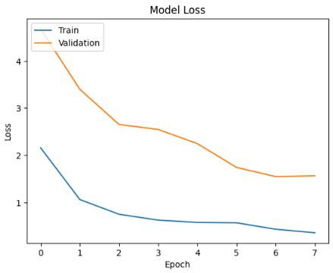

Accuracy: 0.7009063444108762

Precision: 0.7536584532635976

Recall: 0.7800688115338739

F1 Score: 0.70699520606220

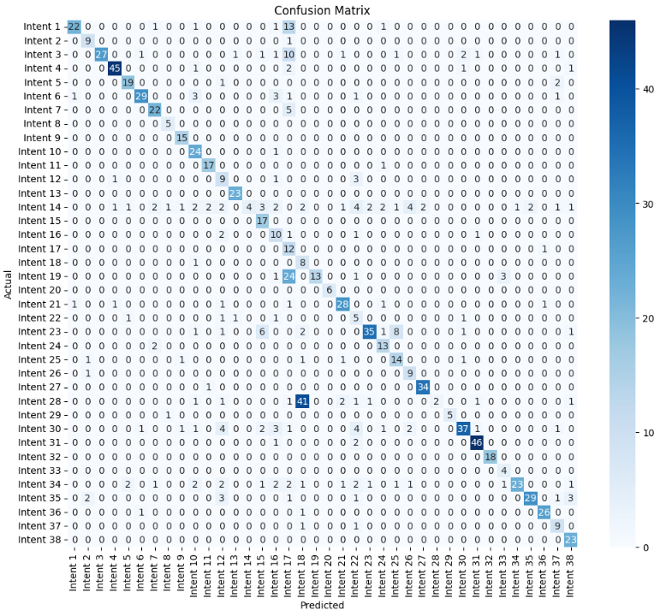

Intent: Account & Customer Information Management

Accuracy: 0.98

Precision: 0.92

Recall: 0.56

F1 Score: 0.70

Intent: After Sales & Service Termination

Accuracy: 0.99

Precision: 0.69

Recall: 0.90

F1 Score: 0.78

Intent: Application Usage

Accuracy: 0.98

Precision: 1.00

Recall: 0.57

F1 Score: 0.73

Intent: Billing

Accuracy: 0.99

Precision: 0.94

Recall: 0.90

F1 Score: 0.92

Intent: Business Training and Webinar

Accuracy: 0.99

Precision: 0.83

Recall: 0.86

F1 Score: 0.84

Intent: Call Center

Accuracy: 0.99

Precision: 0.91

Recall: 0.74

F1 Score: 0.82

Intent: Competitors

Accuracy: 0.99

Precision: 0.79

Recall: 0.81

F1 Score: 0.80

Intent: Customer ID Number

Accuracy: 1.00

Precision: 0.71

Recall: 1.00

F1 Score: 0.83

Intent: Discount & Referral Incentive

Accuracy: 1.00

Precision: 0.83

Recall: 1.00

F1 Score: 0.91

Intent: Disturbance Report

Accuracy: 0.99

Precision: 0.65

Recall: 0.96

F1 Score: 0.77

Intent: FUP Indibiz

Accuracy: 1.00

Precision: 0.85

Recall: 0.94

F1 Score: 0.89

Intent: General Business Information

Accuracy: 0.98

Precision: 0.33

Recall: 0.64

F1 Score: 0.44

Intent: IP Services

Accuracy: 1.00

Precision: 0.92

Recall: 1.00

F1 Score: 0.96

Intent: Indibiz Package

Accuracy: 0.96

Precision: 1.00

Recall: 0.09

F1 Score: 0.17

Intent: Internet Speed

Accuracy: 0.99

Precision: 0.57

Recall: 1.00

F1 Score: 0.72

Intent: Irrelevant Question

Accuracy: 0.98

Precision: 0.37

Recall: 0.67

F1 Score: 0.48

Intent: Modem

Accuracy: 0.94

Precision: 0.16

Recall: 0.92

F1 Score: 0.27

Intent: New Installation

Accuracy: 0.95

Precision: 0.14

Recall: 0.89

F1 Score: 0.24

Intent: Number on Application

Accuracy: 0.97

Precision: 1.00

Recall: 0.31

F1 Score: 0.47

Intent: Optical Distribution Point

Accuracy: 1.00

Precision: 1.00

Recall: 1.00

F1 Score: 1.00

Intent: Order & Subscription Information

Accuracy: 0.99

Precision: 0.82

Recall: 0.82

F1 Score: 0.82

Intent: Others

Accuracy: 0.97

Precision: 0.19

Recall: 0.50

F1 Score: 0.28

Intent: Package Information

Accuracy: 0.97

Precision: 0.90

Recall: 0.62

F1 Score: 0.74

Intent: Package Migration

Accuracy: 0.99

Precision: 0.65

Recall: 0.87

F1 Score: 0.74

Intent: Price

Accuracy: 0.98

Precision: 0.56

Recall: 0.74

F1 Score: 0.64

Intent: Product & Package Differences

Accuracy: 0.99

Precision: 0.56

Recall: 0.90

F1 Score: 0.69

Intent: Product Advantages and Disadvantages

Accuracy: 1.00

Precision: 0.94

Recall: 0.97

F1 Score: 0.96

Intent: Product Installation

Accuracy: 0.95

Precision: 1.00

Recall: 0.04

F1 Score: 0.07

Intent: Product Reseller

Accuracy: 1.00

Precision: 1.00

Recall: 0.83

F1 Score: 0.91

Intent: Products & Services

Accuracy: 0.97

Precision: 0.86

Recall: 0.63

F1 Score: 0.73

Intent: Service Availability

Accuracy: 0.99

Precision: 0.92

Recall: 0.94

F1 Score: 0.93

Intent: Technician Survey

Accuracy: 1.00

Precision: 1.00

Recall: 1.00

F1 Score: 1.00

Intent: Transaction Number

Accuracy: 1.00

Precision: 0.50

Recall: 1.00

F1 Score: 0.67

Intent: Unclear Context

Accuracy: 0.98

Precision: 0.96

Recall: 0.52

F1 Score: 0.68

Intent: Unclear Words

Accuracy: 0.99

Precision: 0.94

Recall: 0.72

F1 Score: 0.82

Intent: Upgrading and Downgrading

Accuracy: 1.00

Precision: 0.93

Recall: 0.93

F1 Score: 0.93

Intent: Vertical Business Education

Accuracy: 0.99

Precision: 0.56

Recall: 0.82

F1 Score: 0.67

Intent: myIndibiz B2B Products

Accuracy: 0.99

Precision: 0.74

Recall: 1.00

F1 Score: 0.85

# Regularization 0,001

import tensorflow as tf

# Hyperparameters yang disarankan

layer_unit = 32 # Kapasitas layer yang lebih besar

dropout_val = 0.1 # Sedikit menurunkan dropout

batch_size = 32 # Batch lebih kecil untuk stabilitas

learning_rate = 1e-6 # Sedikit menurunkan learning rate

initial_lr = 1e-4 # Learning rate awal sebelum warmup

weight_decay = 0.01 # Tetap

gamma = 3 # Meningkatkan gamma untuk penalti kelas minoritas

alpha = 0.25 # Tetap

epochs = 8 # Tetap, sesuaikan sesuai kebutuhan

activation_function = 'gelu'

l2_values = tf.keras.regularizers.l2(0.001)

🟢 Warmup: Setting learning rate to 0.000100

Epoch 1/8

252/252 [==============================] - 169s 513ms/step - loss: 1.6304 - accuracy: 0.6346 - recall: 0.5689 - precision: 0.8209 - f1_score: 0.6018 - val_loss: 0.8418 - val_accuracy: 0.7917 - val_recall: 0.7536 - val_precision: 0.8786 - val_f1_score: 0.7821 - lr: 1.0000e-04

🟢 Warmup: Setting learning rate to 0.000080

Epoch 2/8

252/252 [==============================] - 126s 500ms/step - loss: 0.6236 - accuracy: 0.8609 - recall: 0.8296 - precision: 0.9130 - f1_score: 0.8429 - val_loss: 0.8209 - val_accuracy: 0.8219 - val_recall: 0.7973 - val_precision: 0.8812 - val_f1_score: 0.8233 - lr: 8.0200e-05

🟢 Warmup: Setting learning rate to 0.000060

Epoch 3/8

252/252 [==============================] - 126s 499ms/step - loss: 0.3877 - accuracy: 0.9147 - recall: 0.8991 - precision: 0.9427 - f1_score: 0.9093 - val_loss: 0.7911 - val_accuracy: 0.8589 - val_recall: 0.8511 - val_precision: 0.8827 - val_f1_score: 0.8509 - lr: 6.0400e-05

🟢 Warmup: Setting learning rate to 0.000041

Epoch 4/8

252/252 [==============================] - 126s 500ms/step - loss: 0.2098 - accuracy: 0.9592 - recall: 0.9530 - precision: 0.9721 - f1_score: 0.9586 - val_loss: 0.7562 - val_accuracy: 0.8623 - val_recall: 0.8578 - val_precision: 0.8794 - val_f1_score: 0.8644 - lr: 4.0600e-05

🟢 Warmup: Setting learning rate to 0.000021

Epoch 5/8

252/252 [==============================] - 126s 498ms/step - loss: 0.1311 - accuracy: 0.9817 - recall: 0.9782 - precision: 0.9866 - f1_score: 0.9794 - val_loss: 0.7684 - val_accuracy: 0.8645 - val_recall: 0.8567 - val_precision: 0.8875 - val_f1_score: 0.8581 - lr: 2.0800e-05

🔵 Learning rate after warmup: 0.000021

Epoch 6/8

252/252 [==============================] - 125s 498ms/step - loss: 0.1036 - accuracy: 0.9905 - recall: 0.9888 - precision: 0.9932 - f1_score: 0.9897 - val_loss: 0.7747 - val_accuracy: 0.8735 - val_recall: 0.8667 - val_precision: 0.8866 - val_f1_score: 0.8704 - lr: 2.0800e-05

🔵 Learning rate after warmup: 0.000021

Epoch 7/8

252/252 [==============================] - ETA: 0s - loss: 0.0950 - accuracy: 0.9924 - recall: 0.9918 - precision: 0.9936 - f1_score: 0.9927

Epoch 7: ReduceLROnPlateau reducing learning rate to 1.0400000064691994e-05.

252/252 [==============================] - 125s 498ms/step - loss: 0.0950 - accuracy: 0.9924 - recall: 0.9918 - precision: 0.9936 - f1_score: 0.9927 - val_loss: 0.7839 - val_accuracy: 0.8757 - val_recall: 0.8712 - val_precision: 0.8902 - val_f1_score: 0.8702 - lr: 2.0800e-05

🔵 Learning rate after warmup: 0.000010

Epoch 8/8

252/252 [==============================] - 125s 498ms/step - loss: 0.0877 - accuracy: 0.9951 - recall: 0.9943 - precision: 0.9963 - f1_score: 0.9958 - val_loss: 0.7898 - val_accuracy: 0.8723 - val_recall: 0.8690 - val_precision: 0.8879 - val_f1_score: 0.8601 - lr: 1.0400e-05

28/28 [==============================] - 7s 162ms/step

precision recall f1-score support

Account & Customer Information Management 0.9375 0.8571 0.8955 35

After Sales & Service Termination 0.8889 0.8889 0.8889 9

Application Usage 0.8125 0.9286 0.8667 42

Billing 0.9130 0.9333 0.9231 45

Business Training and Webinar 0.9500 0.9500 0.9500 20

Call Center 0.9412 0.9143 0.9275 35

Competitors 0.9130 0.8750 0.8936 24

Customer ID Number 0.5000 0.5000 0.5000 4

Discount & Referral Incentive 0.9333 1.0000 0.9655 14

Disturbance Report 0.8400 0.9130 0.8750 23

FUP Indibiz 1.0000 1.0000 1.0000 16

General Business Information 0.7273 0.6154 0.6667 13

IP Services 0.9524 0.9524 0.9524 21

Indibiz Package 0.7143 0.7500 0.7317 40

Internet Speed 0.7895 1.0000 0.8824 15

Irrelevant Question 0.6000 0.6429 0.6207 14

Modem 1.0000 0.7500 0.8571 12

New Installation 1.0000 0.8750 0.9333 8

Number on Application 0.9487 0.9737 0.9610 38

Optical Distribution Point 1.0000 1.0000 1.0000 5

Order & Subscription Information 0.8519 0.7419 0.7931 31

Others 0.7500 0.3333 0.4615 9

Package Information 0.9574 0.8824 0.9184 51

Package Migration 0.9167 0.7857 0.8462 14

Price 0.7895 0.8824 0.8333 17

Product & Package Differences 1.0000 0.9000 0.9474 10

Product Advantages and Disadvantages 0.9655 0.9032 0.9333 31

Product Installation 0.9167 0.9565 0.9362 46

Product Reseller 0.8333 1.0000 0.9091 5

Products & Services 0.7097 0.8302 0.7652 53

Service Availability 0.8478 0.8864 0.8667 44

Technician Survey 1.0000 1.0000 1.0000 16

Transaction Number 1.0000 0.7500 0.8571 4

Unclear Context 0.8857 0.7949 0.8378 39

Unclear Words 0.8889 0.8889 0.8889 36

Upgrading and Downgrading 0.8462 0.8800 0.8627 25

Vertical Business Education 0.8000 0.8889 0.8421 9

myIndibiz B2B Products 0.9444 0.8500 0.8947 20

accuracy 0.8723 893

macro avg 0.8754 0.8546 0.8601 893

weighted avg 0.8766 0.8723 0.8717 893

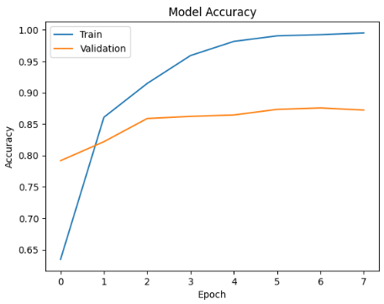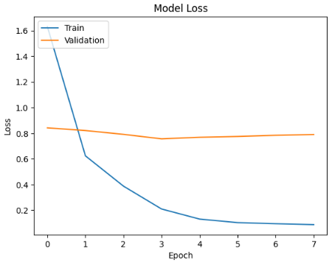

Accuracy: 0.8741188318227593

Precision: 0.8795887297865209

Recall: 0.8620794117224876

F1 Score: 0.8671566770451126

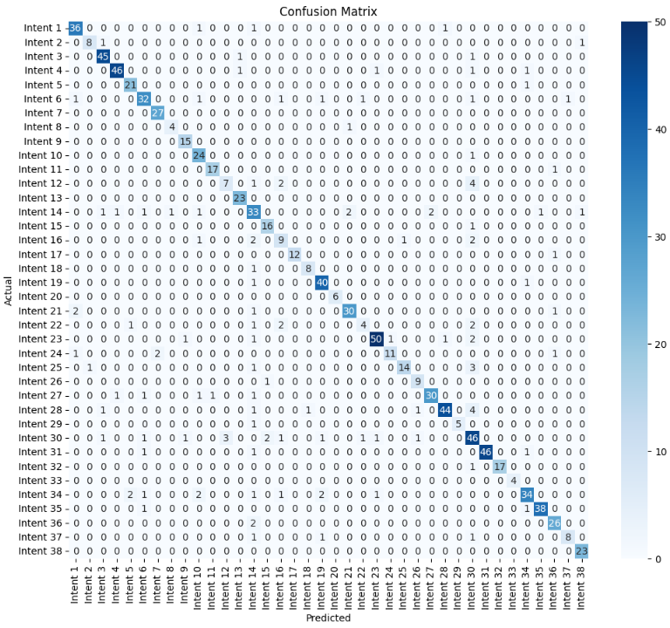

Intent: Account & Customer Information Management

Accuracy: 0.99

Precision: 0.90

Recall: 0.92

F1 Score: 0.91

Intent: After Sales & Service Termination

Accuracy: 1.00

Precision: 0.89

Recall: 0.80

F1 Score: 0.84

Intent: Application Usage

Accuracy: 0.99

Precision: 0.92

Recall: 0.96

F1 Score: 0.94

Intent: Billing

Accuracy: 0.99

Precision: 0.96

Recall: 0.92

F1 Score: 0.94

Intent: Business Training and Webinar

Accuracy: 1.00

Precision: 0.88

Recall: 0.95

F1 Score: 0.91

Intent: Call Center

Accuracy: 0.99

Precision: 0.84

Recall: 0.82

F1 Score: 0.83

Intent: Competitors

Accuracy: 1.00

Precision: 0.93

Recall: 1.00

F1 Score: 0.96

Intent: Customer ID Number

Accuracy: 1.00

Precision: 0.80

Recall: 0.80

F1 Score: 0.80

Intent: Discount & Referral Incentive

Accuracy: 1.00

Precision: 0.88

Recall: 1.00

F1 Score: 0.94

Intent: Disturbance Report

Accuracy: 0.99

Precision: 0.77

Recall: 0.96

F1 Score: 0.86

Intent: FUP Indibiz

Accuracy: 1.00

Precision: 0.94

Recall: 0.94

F1 Score: 0.94

Intent: General Business Information

Accuracy: 0.99

Precision: 0.70

Recall: 0.50

F1 Score: 0.58

Intent: IP Services

Accuracy: 1.00

Precision: 0.92

Recall: 1.00

F1 Score: 0.96

Intent: Indibiz Package

Accuracy: 0.97

Precision: 0.65

Recall: 0.75

F1 Score: 0.69

Intent: Internet Speed

Accuracy: 1.00

Precision: 0.84

Recall: 0.94

F1 Score: 0.89

Intent: Irrelevant Question

Accuracy: 0.99

Precision: 0.56

Recall: 0.60

F1 Score: 0.58

Intent: Modem

Accuracy: 1.00

Precision: 1.00

Recall: 0.92

F1 Score: 0.96

Intent: New Installation

Accuracy: 1.00

Precision: 0.89

Recall: 0.89

F1 Score: 0.89

Intent: Number on Application

Accuracy: 0.99

Precision: 0.89

Recall: 0.95

F1 Score: 0.92

Intent: Optical Distribution Point

Accuracy: 1.00

Precision: 1.00

Recall: 1.00

F1 Score: 1.00

Intent: Order & Subscription Information

Accuracy: 0.99

Precision: 0.91

Recall: 0.88

F1 Score: 0.90

Intent: Others

Accuracy: 0.99

Precision: 0.67

Recall: 0.40

F1 Score: 0.50

Intent: Package Information

Accuracy: 0.99

Precision: 0.94

Recall: 0.89

F1 Score: 0.92

Intent: Package Migration

Accuracy: 0.99

Precision: 0.92

Recall: 0.73

F1 Score: 0.81

Intent: Price

Accuracy: 0.99

Precision: 0.93

Recall: 0.74

F1 Score: 0.82

Intent: Product & Package Differences

Accuracy: 1.00

Precision: 0.82

Recall: 0.90

F1 Score: 0.86

Intent: Product Advantages and Disadvantages

Accuracy: 0.99

Precision: 0.94

Recall: 0.86

F1 Score: 0.90

Intent: Product Installation

Accuracy: 0.99

Precision: 0.96

Recall: 0.85

F1 Score: 0.90

Intent: Product Reseller

Accuracy: 1.00

Precision: 1.00

Recall: 0.83

F1 Score: 0.91

Intent: Products & Services

Accuracy: 0.96

Precision: 0.66

Recall: 0.78

F1 Score: 0.71

Intent: Service Availability

Accuracy: 1.00

Precision: 1.00

Recall: 0.94

F1 Score: 0.97

Intent: Technician Survey

Accuracy: 1.00

Precision: 1.00

Recall: 0.94

F1 Score: 0.97

Intent: Transaction Number

Accuracy: 1.00

Precision: 1.00

Recall: 1.00

F1 Score: 1.00

Intent: Unclear Context

Accuracy: 0.98

Precision: 0.87

Recall: 0.77

F1 Score: 0.82

Intent: Unclear Words

Accuracy: 1.00

Precision: 0.97

Recall: 0.95

F1 Score: 0.96

Intent: Upgrading and Downgrading

Accuracy: 0.99

Precision: 0.87

Recall: 0.93

F1 Score: 0.90

Intent: Vertical Business Education

Accuracy: 1.00

Precision: 0.89

Recall: 0.73

F1 Score: 0.80

Intent: myIndibiz B2B Products

Accuracy: 1.00

Precision: 0.92

Recall: 1.00

F1 Score: 0.96

# Regularization 0,002

🟢 Warmup: Setting learning rate to 0.000100

Epoch 1/8

252/252 [==============================] - 165s 511ms/step - loss: 1.6820 - accuracy: 0.6253 - recall_2: 0.5540 - precision_2: 0.8357 - f1_score: 0.6063 - val_loss: 0.8879 - val_accuracy: 0.8163 - val_recall_2: 0.7592 - val_precision_2: 0.8968 - val_f1_score: 0.8085 - lr: 1.0000e-04

🟢 Warmup: Setting learning rate to 0.000080

Epoch 2/8

252/252 [==============================] - 126s 498ms/step - loss: 0.7189 - accuracy: 0.8498 - recall_2: 0.8171 - precision_2: 0.9085 - f1_score: 0.8360 - val_loss: 0.8340 - val_accuracy: 0.8399 - val_recall_2: 0.8208 - val_precision_2: 0.8853 - val_f1_score: 0.8281 - lr: 8.0200e-05

🟢 Warmup: Setting learning rate to 0.000060

Epoch 3/8

252/252 [==============================] - 125s 497ms/step - loss: 0.4491 - accuracy: 0.9140 - recall_2: 0.8981 - precision_2: 0.9446 - f1_score: 0.9058 - val_loss: 0.8682 - val_accuracy: 0.8511 - val_recall_2: 0.8455 - val_precision_2: 0.8769 - val_f1_score: 0.8415 - lr: 6.0400e-05

🟢 Warmup: Setting learning rate to 0.000041

Epoch 4/8

252/252 [==============================] - 126s 499ms/step - loss: 0.3030 - accuracy: 0.9549 - recall_2: 0.9457 - precision_2: 0.9683 - f1_score: 0.9489 - val_loss: 0.7901 - val_accuracy: 0.8578 - val_recall_2: 0.8499 - val_precision_2: 0.8867 - val_f1_score: 0.8538 - lr: 4.0600e-05

🟢 Warmup: Setting learning rate to 0.000021

Epoch 5/8

252/252 [==============================] - 125s 497ms/step - loss: 0.2035 - accuracy: 0.9811 - recall_2: 0.9769 - precision_2: 0.9863 - f1_score: 0.9805 - val_loss: 0.7943 - val_accuracy: 0.8757 - val_recall_2: 0.8701 - val_precision_2: 0.8931 - val_f1_score: 0.8671 - lr: 2.0800e-05

🔵 Learning rate after warmup: 0.000021

Epoch 6/8

252/252 [==============================] - 125s 497ms/step - loss: 0.1762 - accuracy: 0.9867 - recall_2: 0.9844 - precision_2: 0.9901 - f1_score: 0.9839 - val_loss: 0.8766 - val_accuracy: 0.8712 - val_recall_2: 0.8679 - val_precision_2: 0.8837 - val_f1_score: 0.8704 - lr: 2.0800e-05

🔵 Learning rate after warmup: 0.000021

Epoch 7/8

252/252 [==============================] - ETA: 0s - loss: 0.1635 - accuracy: 0.9918 - recall_2: 0.9907 - precision_2: 0.9939 - f1_score: 0.9923

Epoch 7: ReduceLROnPlateau reducing learning rate to 1.0400000064691994e-05.

252/252 [==============================] - 125s 497ms/step - loss: 0.1635 - accuracy: 0.9918 - recall_2: 0.9907 - precision_2: 0.9939 - f1_score: 0.9923 - val_loss: 0.8608 - val_accuracy: 0.8757 - val_recall_2: 0.8690 - val_precision_2: 0.8869 - val_f1_score: 0.8705 - lr: 2.0800e-05

🔵 Learning rate after warmup: 0.000010

Epoch 8/8

252/252 [==============================] - 125s 497ms/step - loss: 0.1530 - accuracy: 0.9945 - recall_2: 0.9940 - precision_2: 0.9960 - f1_score: 0.9947 - val_loss: 0.8505 - val_accuracy: 0.8768 - val_recall_2: 0.8723 - val_precision_2: 0.8995 - val_f1_score: 0.8722 - lr: 1.0400e-05

28/28 [==============================] - 7s 162ms/step

precision recall f1-score support

Account & Customer Information Management 0.9118 0.8857 0.8986 35

After Sales & Service Termination 1.0000 0.8889 0.9412 9

Application Usage 0.9250 0.8810 0.9024 42

Billing 0.9111 0.9111 0.9111 45

Business Training and Webinar 0.9474 0.9000 0.9231 20

Call Center 0.9412 0.9143 0.9275 35

Competitors 0.9130 0.8750 0.8936 24

Customer ID Number 0.7500 0.7500 0.7500 4

Discount & Referral Incentive 0.8750 1.0000 0.9333 14

Disturbance Report 0.8750 0.9130 0.8936 23

FUP Indibiz 0.8889 1.0000 0.9412 16

General Business Information 0.6154 0.6154 0.6154 13

IP Services 0.9524 0.9524 0.9524 21

Indibiz Package 0.7045 0.7750 0.7381 40

Internet Speed 0.9375 1.0000 0.9677 15

Irrelevant Question 0.6000 0.6429 0.6207 14

Modem 0.8182 0.7500 0.7826 12

New Installation 1.0000 0.8750 0.9333 8

Number on Application 0.9487 0.9737 0.9610 38

Optical Distribution Point 1.0000 1.0000 1.0000 5

Order & Subscription Information 0.8462 0.7097 0.7719 31

Others 0.6250 0.5556 0.5882 9

Package Information 0.9200 0.9020 0.9109 51

Package Migration 0.9167 0.7857 0.8462 14

Price 0.8889 0.9412 0.9143 17

Product & Package Differences 1.0000 0.9000 0.9474 10

Product Advantages and Disadvantages 0.9333 0.9032 0.9180 31

Product Installation 0.9149 0.9348 0.9247 46

Product Reseller 0.8333 1.0000 0.9091 5

Products & Services 0.7544 0.8113 0.7818 53

Service Availability 0.8667 0.8864 0.8764 44

Technician Survey 1.0000 1.0000 1.0000 16

Transaction Number 0.8000 1.0000 0.8889 4

Unclear Context 0.8649 0.8205 0.8421 39

Unclear Words 0.9167 0.9167 0.9167 36

Upgrading and Downgrading 0.8519 0.9200 0.8846 25

Vertical Business Education 0.8000 0.8889 0.8421 9

myIndibiz B2B Products 0.9444 0.8500 0.8947 20

accuracy 0.8768 893

macro avg 0.8735 0.8745 0.8722 893

weighted avg 0.8791 0.8768 0.8769 893

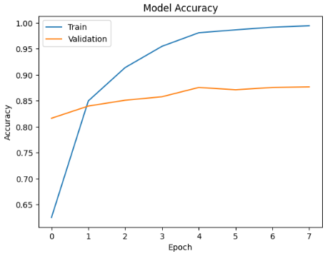

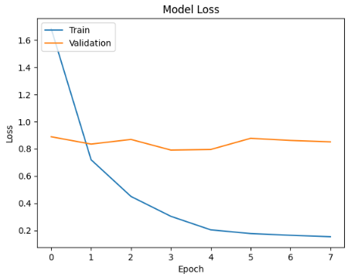

Accuracy: 0.8761329305135952

Precision: 0.8673637329663543

Recall: 0.8613959288869872

F1 Score: 0.8600810281441236

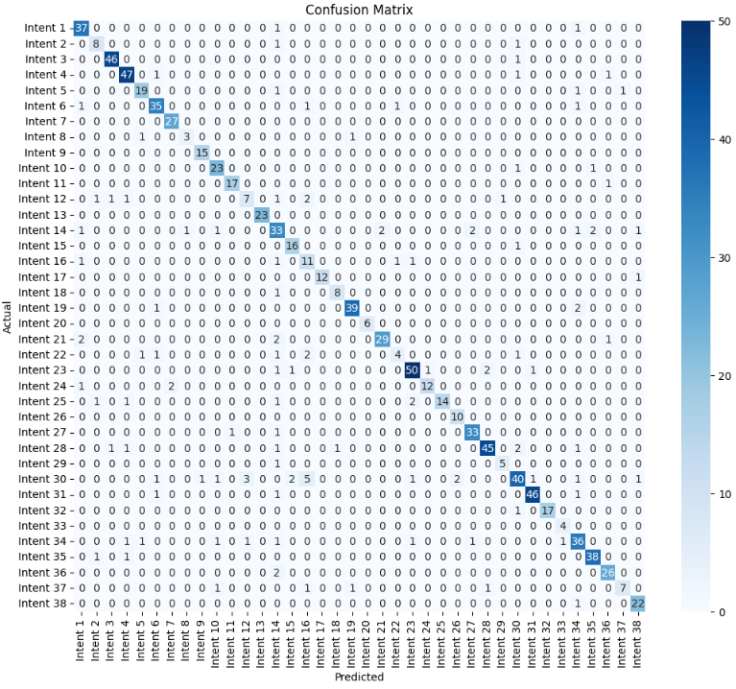

Intent: Account & Customer Information Management

Accuracy: 0.99

Precision: 0.86

Recall: 0.95

F1 Score: 0.90

Intent: After Sales & Service Termination

Accuracy: 0.99

Precision: 0.73

Recall: 0.80

F1 Score: 0.76

Intent: Application Usage

Accuracy: 1.00

Precision: 0.96

Recall: 0.98

F1 Score: 0.97

Intent: Billing

Accuracy: 0.99

Precision: 0.90

Recall: 0.94

F1 Score: 0.92

Intent: Business Training and Webinar

Accuracy: 0.99

Precision: 0.86

Recall: 0.86

F1 Score: 0.86

Intent: Call Center

Accuracy: 0.99

Precision: 0.88

Recall: 0.90

F1 Score: 0.89

Intent: Competitors

Accuracy: 1.00

Precision: 0.93

Recall: 1.00

F1 Score: 0.96

Intent: Customer ID Number

Accuracy: 1.00

Precision: 0.75

Recall: 0.60

F1 Score: 0.67

Intent: Discount & Referral Incentive

Accuracy: 1.00

Precision: 0.94

Recall: 1.00

F1 Score: 0.97

Intent: Disturbance Report

Accuracy: 0.99

Precision: 0.85

Recall: 0.92

F1 Score: 0.88

Intent: FUP Indibiz

Accuracy: 1.00

Precision: 0.94

Recall: 0.94

F1 Score: 0.94

Intent: General Business Information

Accuracy: 0.99

Precision: 0.64

Recall: 0.50

F1 Score: 0.56

Intent: IP Services

Accuracy: 1.00

Precision: 1.00

Recall: 1.00

F1 Score: 1.00

Intent: Indibiz Package

Accuracy: 0.97

Precision: 0.65

Recall: 0.75

F1 Score: 0.69

Intent: Internet Speed

Accuracy: 1.00

Precision: 0.84

Recall: 0.94

F1 Score: 0.89

Intent: Irrelevant Question

Accuracy: 0.98

Precision: 0.50

Recall: 0.73

F1 Score: 0.59

Intent: Modem

Accuracy: 1.00

Precision: 1.00

Recall: 0.92

F1 Score: 0.96

Intent: New Installation

Accuracy: 1.00

Precision: 0.89

Recall: 0.89

F1 Score: 0.89

Intent: Number on Application

Accuracy: 0.99

Precision: 0.95

Recall: 0.93

F1 Score: 0.94

Intent: Optical Distribution Point

Accuracy: 1.00

Precision: 1.00

Recall: 1.00

F1 Score: 1.00

Intent: Order & Subscription Information

Accuracy: 0.99

Precision: 0.94

Recall: 0.85

F1 Score: 0.89

Intent: Others

Accuracy: 0.99

Precision: 0.67

Recall: 0.40

F1 Score: 0.50

Intent: Package Information

Accuracy: 0.99

Precision: 0.91

Recall: 0.89

F1 Score: 0.90

Intent: Package Migration

Accuracy: 1.00

Precision: 0.92

Recall: 0.80

F1 Score: 0.86

Intent: Price

Accuracy: 0.99

Precision: 1.00

Recall: 0.74

F1 Score: 0.85

Intent: Product & Package Differences

Accuracy: 1.00

Precision: 0.83

Recall: 1.00

F1 Score: 0.91

Intent: Product Advantages and Disadvantages

Accuracy: 0.99

Precision: 0.92

Recall: 0.94

F1 Score: 0.93

Intent: Product Installation

Accuracy: 0.99

Precision: 0.94

Recall: 0.87

F1 Score: 0.90

Intent: Product Reseller

Accuracy: 1.00

Precision: 0.83

Recall: 0.83

F1 Score: 0.83

Intent: Products & Services

Accuracy: 0.97

Precision: 0.82

Recall: 0.68

F1 Score: 0.74

Intent: Service Availability

Accuracy: 0.99

Precision: 0.96

Recall: 0.94

F1 Score: 0.95

Intent: Technician Survey

Accuracy: 1.00

Precision: 1.00

Recall: 0.94

F1 Score: 0.97

Intent: Transaction Number

Accuracy: 1.00

Precision: 0.80

Recall: 1.00

F1 Score: 0.89

Intent: Unclear Context

Accuracy: 0.98

Precision: 0.78

Recall: 0.82

F1 Score: 0.80

Intent: Unclear Words

Accuracy: 0.99

Precision: 0.93

Recall: 0.95

F1 Score: 0.94

Intent: Upgrading and Downgrading

Accuracy: 0.99

Precision: 0.90

Recall: 0.93

F1 Score: 0.91

Intent: Vertical Business Education

Accuracy: 0.99

Precision: 0.88

Recall: 0.64

F1 Score: 0.74

Intent: myIndibiz B2B Products

Accuracy: 1.00

Precision: 0.88

Recall: 0.96

F1 Score: 0.92

# Regularization 0,003

🟢 Warmup: Setting learning rate to 0.000100

Epoch 1/8

252/252 [==============================] - 169s 513ms/step - loss: 1.5736 - accuracy: 0.6655 - recall: 0.5989 - precision: 0.8297 - f1_score: 0.6449 - val_loss: 0.9716 - val_accuracy: 0.8085 - val_recall: 0.7727 - val_precision: 0.8625 - val_f1_score: 0.7920 - lr: 1.0000e-04

🟢 Warmup: Setting learning rate to 0.000080

Epoch 2/8

252/252 [==============================] - 126s 499ms/step - loss: 0.7513 - accuracy: 0.8595 - recall: 0.8315 - precision: 0.9101 - f1_score: 0.8435 - val_loss: 0.8551 - val_accuracy: 0.8567 - val_recall: 0.8410 - val_precision: 0.9016 - val_f1_score: 0.8493 - lr: 8.0200e-05

🟢 Warmup: Setting learning rate to 0.000060

Epoch 3/8

252/252 [==============================] - 126s 499ms/step - loss: 0.4949 - accuracy: 0.9190 - recall: 0.9054 - precision: 0.9484 - f1_score: 0.9120 - val_loss: 0.8151 - val_accuracy: 0.8589 - val_recall: 0.8522 - val_precision: 0.9006 - val_f1_score: 0.8357 - lr: 6.0400e-05

🟢 Warmup: Setting learning rate to 0.000041

Epoch 4/8

252/252 [==============================] - 126s 499ms/step - loss: 0.3293 - accuracy: 0.9635 - recall: 0.9568 - precision: 0.9737 - f1_score: 0.9616 - val_loss: 0.8014 - val_accuracy: 0.8723 - val_recall: 0.8611 - val_precision: 0.8963 - val_f1_score: 0.8638 - lr: 4.0600e-05

🟢 Warmup: Setting learning rate to 0.000021

Epoch 5/8

252/252 [==============================] - 125s 498ms/step - loss: 0.2462 - accuracy: 0.9879 - recall: 0.9838 - precision: 0.9923 - f1_score: 0.9874 - val_loss: 0.8168 - val_accuracy: 0.8802 - val_recall: 0.8757 - val_precision: 0.8947 - val_f1_score: 0.8743 - lr: 2.0800e-05

🔵 Learning rate after warmup: 0.000021

Epoch 6/8

252/252 [==============================] - 125s 498ms/step - loss: 0.2271 - accuracy: 0.9915 - recall: 0.9892 - precision: 0.9936 - f1_score: 0.9918 - val_loss: 0.8423 - val_accuracy: 0.8791 - val_recall: 0.8757 - val_precision: 0.8927 - val_f1_score: 0.8730 - lr: 2.0800e-05

🔵 Learning rate after warmup: 0.000021

Epoch 7/8

252/252 [==============================] - ETA: 0s - loss: 0.2221 - accuracy: 0.9933 - recall: 0.9918 - precision: 0.9946 - f1_score: 0.9934

Epoch 7: ReduceLROnPlateau reducing learning rate to 1.0400000064691994e-05.

252/252 [==============================] - 125s 497ms/step - loss: 0.2221 - accuracy: 0.9933 - recall: 0.9918 - precision: 0.9946 - f1_score: 0.9934 - val_loss: 0.8603 - val_accuracy: 0.8824 - val_recall: 0.8802 - val_precision: 0.8932 - val_f1_score: 0.8759 - lr: 2.0800e-05

🔵 Learning rate after warmup: 0.000010

Epoch 8/8

252/252 [==============================] - 125s 498ms/step - loss: 0.2116 - accuracy: 0.9950 - recall: 0.9945 - precision: 0.9960 - f1_score: 0.9954 - val_loss: 0.8722 - val_accuracy: 0.8813 - val_recall: 0.8779 - val_precision: 0.8909 - val_f1_score: 0.8774 - lr: 1.0400e-05

28/28 [==============================] - 7s 162ms/step

precision recall f1-score support

Account & Customer Information Management 0.9706 0.9429 0.9565 35

After Sales & Service Termination 1.0000 0.8889 0.9412 9

Application Usage 0.9000 0.8571 0.8780 42

Billing 0.9318 0.9111 0.9213 45

Business Training and Webinar 0.9444 0.8500 0.8947 20

Call Center 0.9412 0.9143 0.9275 35

Competitors 0.9167 0.9167 0.9167 24

Customer ID Number 0.7500 0.7500 0.7500 4

Discount & Referral Incentive 0.8750 1.0000 0.9333 14

Disturbance Report 0.9130 0.9130 0.9130 23

FUP Indibiz 0.9412 1.0000 0.9697 16

General Business Information 0.7273 0.6154 0.6667 13

IP Services 0.9524 0.9524 0.9524 21

Indibiz Package 0.6531 0.8000 0.7191 40

Internet Speed 0.8824 1.0000 0.9375 15

Irrelevant Question 0.5000 0.6429 0.5625 14

Modem 0.9091 0.8333 0.8696 12

New Installation 1.0000 0.8750 0.9333 8

Number on Application 0.9500 1.0000 0.9744 38

Optical Distribution Point 1.0000 1.0000 1.0000 5

Order & Subscription Information 0.8889 0.7742 0.8276 31

Others 0.5714 0.4444 0.5000 9

Package Information 0.9231 0.9412 0.9320 51

Package Migration 0.9167 0.7857 0.8462 14

Price 0.8889 0.9412 0.9143 17

Product & Package Differences 1.0000 0.9000 0.9474 10

Product Advantages and Disadvantages 0.9655 0.9032 0.9333 31

Product Installation 0.9545 0.9130 0.9333 46

Product Reseller 0.8333 1.0000 0.9091 5

Products & Services 0.6875 0.8302 0.7521 53

Service Availability 0.8667 0.8864 0.8764 44

Technician Survey 1.0000 1.0000 1.0000 16

Transaction Number 1.0000 1.0000 1.0000 4

Unclear Context 0.9697 0.8205 0.8889 39

Unclear Words 0.9167 0.9167 0.9167 36

Upgrading and Downgrading 0.9130 0.8400 0.8750 25

Vertical Business Education 0.7778 0.7778 0.7778 9

myIndibiz B2B Products 0.9444 0.8500 0.8947 20

accuracy 0.8813 893

macro avg 0.8862 0.8734 0.8774 893

weighted avg 0.8886 0.8813 0.8828 893

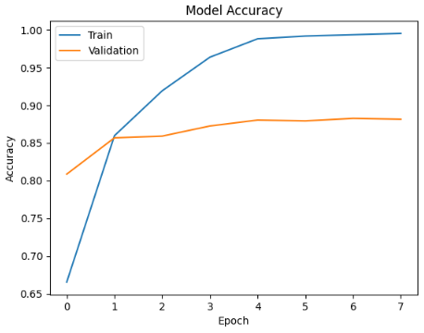

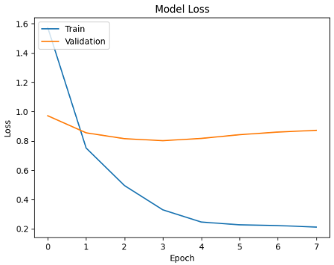

Accuracy: 0.879154078549849

Precision: 0.8704406515666465

Recall: 0.8757408037702553

F1 Score: 0.8688411029781345

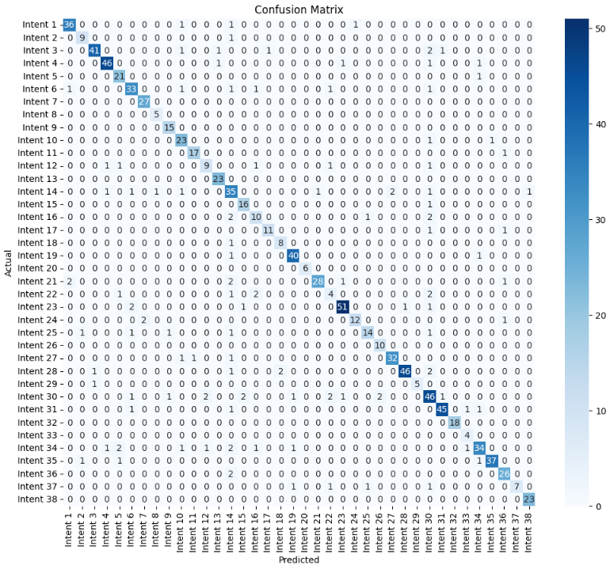

Intent: Account & Customer Information Management

Accuracy: 0.99

Precision: 0.92

Recall: 0.92

F1 Score: 0.92

Intent: After Sales & Service Termination

Accuracy: 1.00

Precision: 0.82

Recall: 0.90

F1 Score: 0.86

Intent: Application Usage

Accuracy: 0.99

Precision: 0.95

Recall: 0.87

F1 Score: 0.91

Intent: Billing

Accuracy: 0.99

Precision: 0.94

Recall: 0.92

F1 Score: 0.93

Intent: Business Training and Webinar

Accuracy: 0.99

Precision: 0.81

Recall: 0.95

F1 Score: 0.88

Intent: Call Center

Accuracy: 0.99

Precision: 0.85

Recall: 0.85

F1 Score: 0.85

Intent: Competitors

Accuracy: 1.00

Precision: 0.93

Recall: 1.00

F1 Score: 0.96

Intent: Customer ID Number

Accuracy: 1.00

Precision: 0.83

Recall: 1.00

F1 Score: 0.91

Intent: Discount & Referral Incentive

Accuracy: 1.00

Precision: 0.88

Recall: 1.00

F1 Score: 0.94

Intent: Disturbance Report

Accuracy: 0.99

Precision: 0.79

Recall: 0.92

F1 Score: 0.85

Intent: FUP Indibiz

Accuracy: 1.00

Precision: 0.94

Recall: 0.94

F1 Score: 0.94

Intent: General Business Information

Accuracy: 0.99

Precision: 0.75

Recall: 0.64

F1 Score: 0.69

Intent: IP Services

Accuracy: 1.00

Precision: 0.92

Recall: 1.00

F1 Score: 0.96

Intent: Indibiz Package

Accuracy: 0.97

Precision: 0.66

Recall: 0.80

F1 Score: 0.72

Intent: Internet Speed

Accuracy: 1.00

Precision: 0.84

Recall: 0.94

F1 Score: 0.89

Intent: Irrelevant Question

Accuracy: 0.99

Precision: 0.67

Recall: 0.67

F1 Score: 0.67

Intent: Modem

Accuracy: 1.00

Precision: 0.92

Recall: 0.85

F1 Score: 0.88

Intent: New Installation

Accuracy: 1.00

Precision: 0.80

Recall: 0.89

F1 Score: 0.84

Intent: Number on Application

Accuracy: 0.99

Precision: 0.93

Recall: 0.95

F1 Score: 0.94

Intent: Optical Distribution Point

Accuracy: 1.00

Precision: 1.00

Recall: 1.00

F1 Score: 1.00

Intent: Order & Subscription Information

Accuracy: 0.99

Precision: 0.97

Recall: 0.82

F1 Score: 0.89

Intent: Others

Accuracy: 0.99

Precision: 0.44

Recall: 0.40

F1 Score: 0.42

Intent: Package Information

Accuracy: 0.99

Precision: 0.94

Recall: 0.91

F1 Score: 0.93

Intent: Package Migration

Accuracy: 1.00

Precision: 0.92

Recall: 0.80

F1 Score: 0.86

Intent: Price

Accuracy: 0.99

Precision: 0.88

Recall: 0.74

F1 Score: 0.80

Intent: Product & Package Differences

Accuracy: 1.00

Precision: 0.83

Recall: 1.00

F1 Score: 0.91

Intent: Product Advantages and Disadvantages

Accuracy: 0.99

Precision: 0.94

Recall: 0.91

F1 Score: 0.93

Intent: Product Installation

Accuracy: 0.99

Precision: 0.98

Recall: 0.88

F1 Score: 0.93

Intent: Product Reseller

Accuracy: 1.00

Precision: 1.00

Recall: 0.83

F1 Score: 0.91

Intent: Products & Services

Accuracy: 0.97

Precision: 0.72

Recall: 0.78

F1 Score: 0.75

Intent: Service Availability

Accuracy: 0.99

Precision: 0.96

Recall: 0.92

F1 Score: 0.94

Intent: Technician Survey

Accuracy: 1.00

Precision: 1.00

Recall: 1.00

F1 Score: 1.00

Intent: Transaction Number

Accuracy: 1.00

Precision: 0.67

Recall: 1.00

F1 Score: 0.80

Intent: Unclear Context

Accuracy: 0.98

Precision: 0.87

Recall: 0.77

F1 Score: 0.82

Intent: Unclear Words

Accuracy: 1.00

Precision: 0.97

Recall: 0.93

F1 Score: 0.95

Intent: Upgrading and Downgrading

Accuracy: 0.99

Precision: 0.87

Recall: 0.93

F1 Score: 0.90

Intent: Vertical Business Education

Accuracy: 1.00

Precision: 1.00

Recall: 0.64

F1 Score: 0.78

Intent: myIndibiz B2B Products

Accuracy: 1.00

Precision: 0.96

Recall: 1.00

F1 Score: 0.98

# Dropout 0,1 = Regularization 0,003 (BEST)

# Dropout 0,2

🟢 Warmup: Setting learning rate to 0.000100

Epoch 1/8

252/252 [==============================] - 166s 512ms/step - loss: 1.7248 - accuracy: 0.6367 - recall_1: 0.5711 - precision_1: 0.8176 - f1_score: 0.6174 - val_loss: 1.1190 - val_accuracy: 0.7615 - val_recall_1: 0.7279 - val_precision_1: 0.8442 - val_f1_score: 0.7414 - lr: 1.0000e-04

🟢 Warmup: Setting learning rate to 0.000080

Epoch 2/8

252/252 [==============================] - 126s 500ms/step - loss: 0.8269 - accuracy: 0.8437 - recall_1: 0.8107 - precision_1: 0.8976 - f1_score: 0.8278 - val_loss: 0.9713 - val_accuracy: 0.8275 - val_recall_1: 0.8052 - val_precision_1: 0.8673 - val_f1_score: 0.8208 - lr: 8.0200e-05

🟢 Warmup: Setting learning rate to 0.000060

Epoch 3/8

252/252 [==============================] - 126s 499ms/step - loss: 0.5379 - accuracy: 0.9141 - recall_1: 0.8960 - precision_1: 0.9433 - f1_score: 0.9065 - val_loss: 0.8548 - val_accuracy: 0.8578 - val_recall_1: 0.8499 - val_precision_1: 0.8867 - val_f1_score: 0.8523 - lr: 6.0400e-05

🟢 Warmup: Setting learning rate to 0.000041

Epoch 4/8

252/252 [==============================] - 125s 498ms/step - loss: 0.3637 - accuracy: 0.9564 - recall_1: 0.9465 - precision_1: 0.9699 - f1_score: 0.9538 - val_loss: 0.8672 - val_accuracy: 0.8634 - val_recall_1: 0.8522 - val_precision_1: 0.8869 - val_f1_score: 0.8557 - lr: 4.0600e-05

🟢 Warmup: Setting learning rate to 0.000021

Epoch 5/8

252/252 [==============================] - 125s 498ms/step - loss: 0.2758 - accuracy: 0.9780 - recall_1: 0.9734 - precision_1: 0.9851 - f1_score: 0.9776 - val_loss: 0.8830 - val_accuracy: 0.8712 - val_recall_1: 0.8645 - val_precision_1: 0.8946 - val_f1_score: 0.8613 - lr: 2.0800e-05

🔵 Learning rate after warmup: 0.000021

Epoch 6/8

252/252 [==============================] - ETA: 0s - loss: 0.2425 - accuracy: 0.9889 - recall_1: 0.9858 - precision_1: 0.9919 - f1_score: 0.9883

Epoch 6: ReduceLROnPlateau reducing learning rate to 1.0400000064691994e-05.

252/252 [==============================] - 125s 498ms/step - loss: 0.2425 - accuracy: 0.9889 - recall_1: 0.9858 - precision_1: 0.9919 - f1_score: 0.9883 - val_loss: 0.9150 - val_accuracy: 0.8712 - val_recall_1: 0.8634 - val_precision_1: 0.8852 - val_f1_score: 0.8634 - lr: 2.0800e-05

🔵 Learning rate after warmup: 0.000010

Epoch 7/8

252/252 [==============================] - 126s 498ms/step - loss: 0.2205 - accuracy: 0.9934 - recall_1: 0.9924 - precision_1: 0.9963 - f1_score: 0.9940 - val_loss: 0.9085 - val_accuracy: 0.8656 - val_recall_1: 0.8623 - val_precision_1: 0.8881 - val_f1_score: 0.8621 - lr: 1.0400e-05

🔵 Learning rate after warmup: 0.000010

Epoch 8/8

252/252 [==============================] - ETA: 0s - loss: 0.2151 - accuracy: 0.9953 - recall_1: 0.9946 - precision_1: 0.9961 - f1_score: 0.9960Restoring model weights from the end of the best epoch: 3.

252/252 [==============================] - 126s 500ms/step - loss: 0.2151 - accuracy: 0.9953 - recall_1: 0.9946 - precision_1: 0.9961 - f1_score: 0.9960 - val_loss: 0.9275 - val_accuracy: 0.8667 - val_recall_1: 0.8645 - val_precision_1: 0.8823 - val_f1_score: 0.8601 - lr: 1.0400e-05

Epoch 8: early stopping

28/28 [==============================] - 7s 161ms/step

precision recall f1-score support

Account & Customer Information Management 0.9667 0.8286 0.8923 35

After Sales & Service Termination 0.8889 0.8889 0.8889 9

Application Usage 0.9750 0.9286 0.9512 42

Billing 0.9535 0.9111 0.9318 45

Business Training and Webinar 0.9474 0.9000 0.9231 20

Call Center 0.7674 0.9429 0.8462 35

Competitors 0.8462 0.9167 0.8800 24

Customer ID Number 0.6000 0.7500 0.6667 4

Discount & Referral Incentive 1.0000 1.0000 1.0000 14

Disturbance Report 0.9524 0.8696 0.9091 23

FUP Indibiz 0.9412 1.0000 0.9697 16

General Business Information 0.5000 0.3077 0.3810 13

IP Services 0.9524 0.9524 0.9524 21

Indibiz Package 0.6154 0.8000 0.6957 40

Internet Speed 0.7500 1.0000 0.8571 15

Irrelevant Question 0.5333 0.5714 0.5517 14

Modem 0.9000 0.7500 0.8182 12

New Installation 0.8889 1.0000 0.9412 8

Number on Application 1.0000 0.9474 0.9730 38

Optical Distribution Point 1.0000 1.0000 1.0000 5

Order & Subscription Information 0.8846 0.7419 0.8070 31

Others 1.0000 0.3333 0.5000 9

Package Information 0.8723 0.8039 0.8367 51

Package Migration 0.9167 0.7857 0.8462 14

Price 0.8333 0.8824 0.8571 17

Product & Package Differences 1.0000 0.8000 0.8889 10

Product Advantages and Disadvantages 0.9655 0.9032 0.9333 31

Product Installation 0.9333 0.9130 0.9231 46

Product Reseller 0.8333 1.0000 0.9091 5

Products & Services 0.8261 0.7170 0.7677 53

Service Availability 0.8298 0.8864 0.8571 44

Technician Survey 1.0000 1.0000 1.0000 16

Transaction Number 1.0000 1.0000 1.0000 4

Unclear Context 0.6667 0.8205 0.7356 39

Unclear Words 0.8718 0.9444 0.9067 36

Upgrading and Downgrading 0.8400 0.8400 0.8400 25

Vertical Business Education 0.8182 1.0000 0.9000 9

myIndibiz B2B Products 0.8500 0.8500 0.8500 20

accuracy 0.8578 893

macro avg 0.8663 0.8549 0.8523 893

weighted avg 0.8666 0.8578 0.8571 893

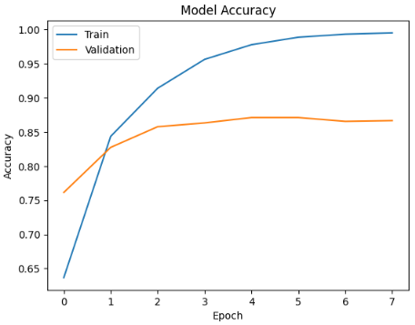

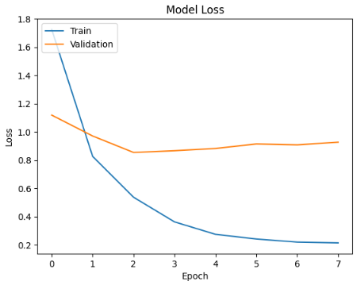

Accuracy: 0.8559919436052367

Precision: 0.8566651853816725

Recall: 0.8447000123396271

F1 Score: 0.8463594629287217

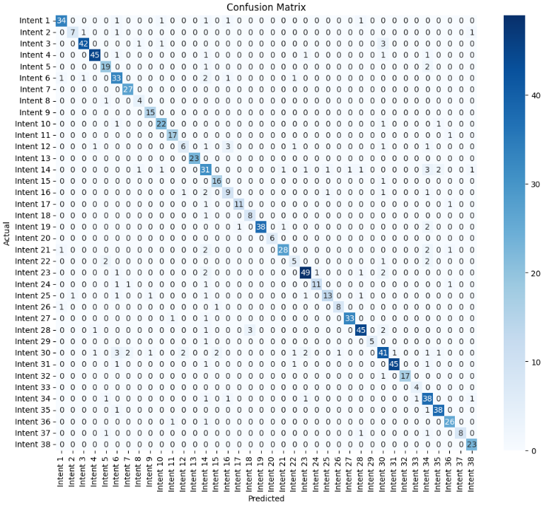

Intent: Account & Customer Information Management

Accuracy: 0.99

Precision: 0.92

Recall: 0.87

F1 Score: 0.89

Intent: After Sales & Service Termination

Accuracy: 1.00

Precision: 0.88

Recall: 0.70

F1 Score: 0.78

Intent: Application Usage

Accuracy: 0.99

Precision: 0.95

Recall: 0.89

F1 Score: 0.92

Intent: Billing

Accuracy: 0.99

Precision: 0.94

Recall: 0.90

F1 Score: 0.92

Intent: Business Training and Webinar

Accuracy: 0.99

Precision: 0.79

Recall: 0.86

F1 Score: 0.83

Intent: Call Center

Accuracy: 0.98

Precision: 0.73

Recall: 0.85

F1 Score: 0.79

Intent: Competitors

Accuracy: 1.00

Precision: 0.90

Recall: 1.00

F1 Score: 0.95

Intent: Customer ID Number

Accuracy: 1.00

Precision: 0.67

Recall: 0.80

F1 Score: 0.73

Intent: Discount & Referral Incentive

Accuracy: 1.00

Precision: 0.88

Recall: 1.00

F1 Score: 0.94

Intent: Disturbance Report

Accuracy: 0.99

Precision: 0.88

Recall: 0.88

F1 Score: 0.88

Intent: FUP Indibiz

Accuracy: 1.00

Precision: 0.89

Recall: 0.94

F1 Score: 0.92

Intent: General Business Information

Accuracy: 0.99

Precision: 0.67

Recall: 0.43

F1 Score: 0.52

Intent: IP Services

Accuracy: 1.00

Precision: 1.00

Recall: 1.00

F1 Score: 1.00

Intent: Indibiz Package

Accuracy: 0.96

Precision: 0.58

Recall: 0.70

F1 Score: 0.64

Intent: Internet Speed

Accuracy: 1.00

Precision: 0.84

Recall: 0.94

F1 Score: 0.89

Intent: Irrelevant Question

Accuracy: 0.99

Precision: 0.60

Recall: 0.60

F1 Score: 0.60

Intent: Modem

Accuracy: 1.00

Precision: 0.92

Recall: 0.85

F1 Score: 0.88

Intent: New Installation

Accuracy: 1.00

Precision: 0.73

Recall: 0.89

F1 Score: 0.80

Intent: Number on Application

Accuracy: 1.00

Precision: 1.00

Recall: 0.90

F1 Score: 0.95

Intent: Optical Distribution Point

Accuracy: 1.00

Precision: 1.00

Recall: 1.00

F1 Score: 1.00

Intent: Order & Subscription Information

Accuracy: 0.99

Precision: 0.93

Recall: 0.82

F1 Score: 0.87

Intent: Others

Accuracy: 0.99

Precision: 0.56

Recall: 0.50

F1 Score: 0.53

Intent: Package Information

Accuracy: 0.99

Precision: 0.89

Recall: 0.88

F1 Score: 0.88

Intent: Package Migration

Accuracy: 0.99

Precision: 0.92

Recall: 0.73

F1 Score: 0.81

Intent: Price

Accuracy: 0.99

Precision: 0.87

Recall: 0.68

F1 Score: 0.76

Intent: Product & Package Differences

Accuracy: 1.00

Precision: 0.89

Recall: 0.80

F1 Score: 0.84

Intent: Product Advantages and Disadvantages

Accuracy: 1.00

Precision: 0.97

Recall: 0.94

F1 Score: 0.96

Intent: Product Installation

Accuracy: 0.99

Precision: 0.90

Recall: 0.87

F1 Score: 0.88

Intent: Product Reseller

Accuracy: 1.00

Precision: 1.00

Recall: 0.83

F1 Score: 0.91

Intent: Products & Services

Accuracy: 0.97

Precision: 0.75

Recall: 0.69

F1 Score: 0.72

Intent: Service Availability

Accuracy: 0.99

Precision: 0.98

Recall: 0.92

F1 Score: 0.95

Intent: Technician Survey

Accuracy: 1.00

Precision: 1.00

Recall: 0.94

F1 Score: 0.97

Intent: Transaction Number

Accuracy: 1.00

Precision: 0.80

Recall: 1.00

F1 Score: 0.89

Intent: Unclear Context

Accuracy: 0.98

Precision: 0.68

Recall: 0.86

F1 Score: 0.76

Intent: Unclear Words

Accuracy: 0.99

Precision: 0.90

Recall: 0.95

F1 Score: 0.93

Intent: Upgrading and Downgrading

Accuracy: 0.99

Precision: 0.87

Recall: 0.93

F1 Score: 0.90

Intent: Vertical Business Education

Accuracy: 1.00

Precision: 1.00

Recall: 0.73

F1 Score: 0.84

Intent: myIndibiz B2B Products

Accuracy: 1.00

Precision: 0.88

Recall: 1.00

F1 Score: 0.94

# Dropout 0,3

🟢 Warmup: Setting learning rate to 0.000100

Epoch 1/8

252/252 [==============================] - 170s 515ms/step - loss: 2.0373 - accuracy: 0.5704 - recall: 0.4983 - precision: 0.8092 - f1_score: 0.5391 - val_loss: 0.9556 - val_accuracy: 0.8052 - val_recall: 0.7850 - val_precision: 0.8784 - val_f1_score: 0.7890 - lr: 1.0000e-04

🟢 Warmup: Setting learning rate to 0.000080

Epoch 2/8

252/252 [==============================] - 126s 500ms/step - loss: 0.8743 - accuracy: 0.8378 - recall: 0.8103 - precision: 0.8983 - f1_score: 0.8169 - val_loss: 0.8647 - val_accuracy: 0.8499 - val_recall: 0.8309 - val_precision: 0.8929 - val_f1_score: 0.8442 - lr: 8.0200e-05

🟢 Warmup: Setting learning rate to 0.000060

Epoch 3/8

252/252 [==============================] - 126s 499ms/step - loss: 0.5610 - accuracy: 0.9069 - recall: 0.8906 - precision: 0.9397 - f1_score: 0.8973 - val_loss: 0.8690 - val_accuracy: 0.8600 - val_recall: 0.8488 - val_precision: 0.8845 - val_f1_score: 0.8361 - lr: 6.0400e-05

🟢 Warmup: Setting learning rate to 0.000041

Epoch 4/8

252/252 [==============================] - 126s 499ms/step - loss: 0.4039 - accuracy: 0.9456 - recall: 0.9349 - precision: 0.9599 - f1_score: 0.9407 - val_loss: 0.8680 - val_accuracy: 0.8735 - val_recall: 0.8690 - val_precision: 0.8961 - val_f1_score: 0.8793 - lr: 4.0600e-05

🟢 Warmup: Setting learning rate to 0.000021

Epoch 5/8

252/252 [==============================] - ETA: 0s - loss: 0.2878 - accuracy: 0.9749 - recall: 0.9695 - precision: 0.9814 - f1_score: 0.9729

Epoch 5: ReduceLROnPlateau reducing learning rate to 1.0400000064691994e-05.

252/252 [==============================] - 126s 499ms/step - loss: 0.2878 - accuracy: 0.9749 - recall: 0.9695 - precision: 0.9814 - f1_score: 0.9729 - val_loss: 0.8714 - val_accuracy: 0.8679 - val_recall: 0.8634 - val_precision: 0.8862 - val_f1_score: 0.8632 - lr: 2.0800e-05

🔵 Learning rate after warmup: 0.000010

Epoch 6/8

252/252 [==============================] - 126s 499ms/step - loss: 0.2433 - accuracy: 0.9884 - recall: 0.9853 - precision: 0.9911 - f1_score: 0.9880 - val_loss: 0.8859 - val_accuracy: 0.8690 - val_recall: 0.8656 - val_precision: 0.8865 - val_f1_score: 0.8667 - lr: 1.0400e-05

🔵 Learning rate after warmup: 0.000010

Epoch 7/8

252/252 [==============================] - ETA: 0s - loss: 0.2294 - accuracy: 0.9912 - recall: 0.9894 - precision: 0.9936 - f1_score: 0.9901Restoring model weights from the end of the best epoch: 2.

252/252 [==============================] - 126s 501ms/step - loss: 0.2294 - accuracy: 0.9912 - recall: 0.9894 - precision: 0.9936 - f1_score: 0.9901 - val_loss: 0.8950 - val_accuracy: 0.8723 - val_recall: 0.8667 - val_precision: 0.8886 - val_f1_score: 0.8657 - lr: 1.0400e-05

Epoch 7: early stopping

28/28 [==============================] - 7s 162ms/step

precision recall f1-score support

Account & Customer Information Management 0.8788 0.8286 0.8529 35

After Sales & Service Termination 1.0000 0.8889 0.9412 9

Application Usage 0.8333 0.8333 0.8333 42

Billing 0.9545 0.9333 0.9438 45

Business Training and Webinar 0.8750 0.7000 0.7778 20

Call Center 0.8889 0.9143 0.9014 35

Competitors 0.9130 0.8750 0.8936 24

Customer ID Number 0.6667 1.0000 0.8000 4

Discount & Referral Incentive 1.0000 1.0000 1.0000 14

Disturbance Report 1.0000 0.8696 0.9302 23

FUP Indibiz 1.0000 1.0000 1.0000 16

General Business Information 0.4545 0.7692 0.5714 13

IP Services 0.9524 0.9524 0.9524 21

Indibiz Package 0.5625 0.6750 0.6136 40

Internet Speed 0.7895 1.0000 0.8824 15

Irrelevant Question 0.4211 0.5714 0.4848 14

Modem 1.0000 0.5833 0.7368 12

New Installation 1.0000 0.8750 0.9333 8

Number on Application 1.0000 0.9737 0.9867 38

Optical Distribution Point 1.0000 1.0000 1.0000 5

Order & Subscription Information 1.0000 0.6129 0.7600 31

Others 0.7143 0.5556 0.6250 9

Package Information 0.9057 0.9412 0.9231 51

Package Migration 0.9091 0.7143 0.8000 14

Price 0.7895 0.8824 0.8333 17

Product & Package Differences 1.0000 0.9000 0.9474 10

Product Advantages and Disadvantages 0.9118 1.0000 0.9538 31

Product Installation 0.8036 0.9783 0.8824 46

Product Reseller 1.0000 1.0000 1.0000 5

Products & Services 0.7018 0.7547 0.7273 53

Service Availability 0.9070 0.8864 0.8966 44

Technician Survey 1.0000 0.9375 0.9677 16

Transaction Number 1.0000 0.2500 0.4000 4

Unclear Context 0.7941 0.6923 0.7397 39

Unclear Words 0.8947 0.9444 0.9189 36

Upgrading and Downgrading 0.8400 0.8400 0.8400 25

Vertical Business Education 1.0000 0.8889 0.9412 9

myIndibiz B2B Products 1.0000 0.8000 0.8889 20

accuracy 0.8499 893

macro avg 0.8779 0.8374 0.8442 893

weighted avg 0.8660 0.8499 0.8514 893

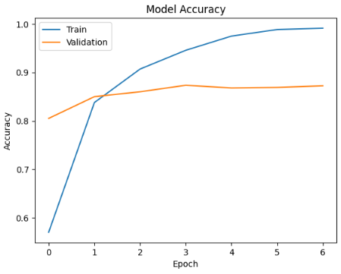

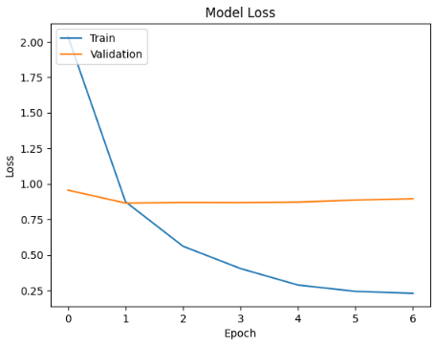

Accuracy: 0.8499496475327291

Precision: 0.8568317308471856

Recall: 0.8304841219881284

F1 Score: 0.8371581543567675

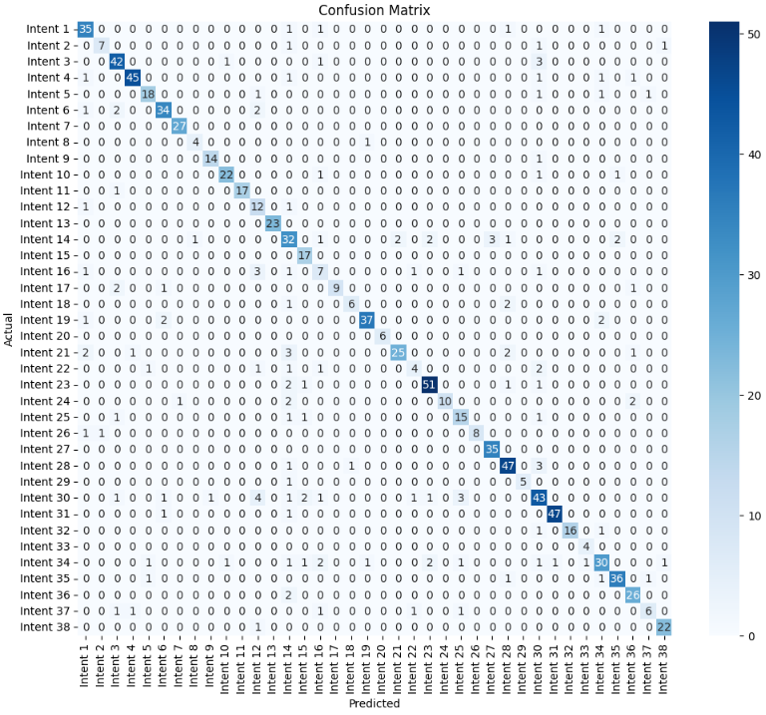

Intent: Account & Customer Information Management

Accuracy: 0.99

Precision: 0.81

Recall: 0.90

F1 Score: 0.85

Intent: After Sales & Service Termination

Accuracy: 1.00

Precision: 0.88

Recall: 0.70

F1 Score: 0.78

Intent: Application Usage

Accuracy: 0.99

Precision: 0.84

Recall: 0.89

F1 Score: 0.87

Intent: Billing

Accuracy: 0.99

Precision: 0.96

Recall: 0.90

F1 Score: 0.93

Intent: Business Training and Webinar

Accuracy: 0.99

Precision: 0.86

Recall: 0.82

F1 Score: 0.84

Intent: Call Center

Accuracy: 0.99

Precision: 0.87

Recall: 0.87

F1 Score: 0.87

Intent: Competitors

Accuracy: 1.00

Precision: 0.96

Recall: 1.00

F1 Score: 0.98

Intent: Customer ID Number

Accuracy: 1.00

Precision: 0.80

Recall: 0.80

F1 Score: 0.80

Intent: Discount & Referral Incentive

Accuracy: 1.00

Precision: 0.93

Recall: 0.93

F1 Score: 0.93

Intent: Disturbance Report

Accuracy: 0.99

Precision: 0.92

Recall: 0.88

F1 Score: 0.90

Intent: FUP Indibiz

Accuracy: 1.00

Precision: 1.00

Recall: 0.94

F1 Score: 0.97

Intent: General Business Information

Accuracy: 0.99

Precision: 0.50

Recall: 0.86

F1 Score: 0.63

Intent: IP Services

Accuracy: 1.00

Precision: 1.00

Recall: 1.00

F1 Score: 1.00

Intent: Indibiz Package

Accuracy: 0.97

Precision: 0.59

Recall: 0.73

F1 Score: 0.65

Intent: Internet Speed

Accuracy: 0.99

Precision: 0.77

Recall: 1.00

F1 Score: 0.87

Intent: Irrelevant Question

Accuracy: 0.98

Precision: 0.44

Recall: 0.47

F1 Score: 0.45

Intent: Modem

Accuracy: 1.00

Precision: 1.00

Recall: 0.69

F1 Score: 0.82

Intent: New Installation

Accuracy: 1.00

Precision: 0.86

Recall: 0.67

F1 Score: 0.75

Intent: Number on Application

Accuracy: 0.99

Precision: 0.95

Recall: 0.88

F1 Score: 0.91

Intent: Optical Distribution Point

Accuracy: 1.00

Precision: 1.00

Recall: 1.00

F1 Score: 1.00

Intent: Order & Subscription Information

Accuracy: 0.99

Precision: 0.93

Recall: 0.74

F1 Score: 0.82

Intent: Others

Accuracy: 0.99

Precision: 0.57

Recall: 0.40

F1 Score: 0.47

Intent: Package Information

Accuracy: 0.99

Precision: 0.91

Recall: 0.91

F1 Score: 0.91

Intent: Package Migration

Accuracy: 0.99

Precision: 1.00

Recall: 0.67

F1 Score: 0.80

Intent: Price

Accuracy: 0.99

Precision: 0.71

Recall: 0.79

F1 Score: 0.75

Intent: Product & Package Differences

Accuracy: 1.00

Precision: 1.00

Recall: 0.80

F1 Score: 0.89

Intent: Product Advantages and Disadvantages

Accuracy: 1.00

Precision: 0.92

Recall: 1.00

F1 Score: 0.96

Intent: Product Installation

Accuracy: 0.99

Precision: 0.85

Recall: 0.90

F1 Score: 0.88

Intent: Product Reseller

Accuracy: 1.00

Precision: 1.00

Recall: 0.83

F1 Score: 0.91

Intent: Products & Services

Accuracy: 0.97

Precision: 0.70

Recall: 0.73

F1 Score: 0.72

Intent: Service Availability

Accuracy: 1.00

Precision: 0.98

Recall: 0.96

F1 Score: 0.97

Intent: Technician Survey

Accuracy: 1.00

Precision: 1.00

Recall: 0.89

F1 Score: 0.94

Intent: Transaction Number

Accuracy: 1.00

Precision: 0.80

Recall: 1.00

F1 Score: 0.89

Intent: Unclear Context

Accuracy: 0.98

Precision: 0.81

Recall: 0.68

F1 Score: 0.74

Intent: Unclear Words

Accuracy: 0.99

Precision: 0.92

Recall: 0.90

F1 Score: 0.91

Intent: Upgrading and Downgrading

Accuracy: 0.99

Precision: 0.84

Recall: 0.93

F1 Score: 0.88

Intent: Vertical Business Education

Accuracy: 0.99

Precision: 0.75

Recall: 0.55

F1 Score: 0.63

Intent: myIndibiz B2B Products

Accuracy: 1.00

Precision: 0.92

Recall: 0.96

F1 Score: 0.94